Protocol for Sampling and Sample Analysis

PONDSCAPE

Towards a sustainable management of pond diversity at the landscape level

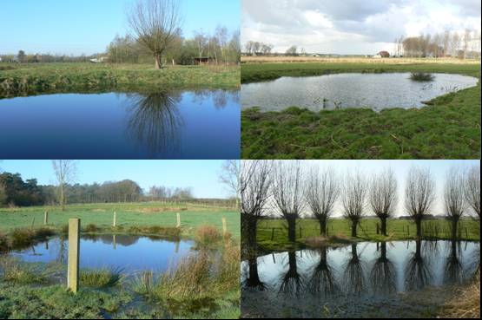

December 2007
Content

1. Summary 3
2. Selection of the model systems 3
2.1. Multi-scale survey 3
2.2. Detailed case study of a high density pond cluster 4
2.3. Evaluation of management techniques 5
2.4. Evaluation of pollution 5
2.4.1. Dynamics in the pesticide loads 5
2.4.2. Evaluation of pollution incidence by estrogen-like properties 5
2.4.3. Effects of pond management on the bio-availability of pollutants 5
3. In the field 5
3.1. Collection of background information 5
3.2. Collection of samples 6
3.2.1. Water (physical and chemical analyses, bacterio- and phytoplankton) 6
3.2.2. Zooplankton 7
3.2.3. Phytobenthos 8
3.2.4. Zoobenthos 8
3.2.5. Fish 8
3.2.6. Snails (and parasites) 8
3.2.7. Macro-invertebrates 9
3.2.8. Amphibians 9
3.2.9. Phanerogams 10
3.2.10. Microbes (ecosystem functioning) 10
3.2.11. Sequence of work 10
4. In the laboratory 11
4.1. Water 11
4.2. Bacteria 13
4.3. Phytoplankton and phytobenthos 13
4.3.1. Phytoplankton 13
4.3.2. Phytobenthos 14
4.4. Zooplankton 14
4.5. Zoobenthos 14
4.6. Macro-invertebrates 14
4.7. Amphibia 15
4.8. Waterplants 15
4.9. Microbes 15
4.10. Parasites 16
4.10.1. Intermediate host: Snails 16
4.10.2. Final host: Cattle 17
4.11. PCB’s 17
4.12. Heavy metals 17
4.13. Pesticides 17
4.14. Oestrogen-like properties 18
Reference list 18
ANNEX I: Field notes form 21
ANNEX II: Materials needed per organism group for field sampling 23

1. Summary

The present protocol is a deliverable of the project ‘Towards a sustainable management of pond diversity at the landscape level (PONDSCAPE)’.

The present protocol was developed describing the standardised research methodologies applied to reach the objectives of the study. The protocol specifies which model systems were studied at which level of biodiversity (gene, taxon, ecosystem), how samples were taken for the different groups of organisms and how these samples were processed. The protocol includes details related to the frequency of sampling, the number and choice of sampling stations, the sampling equipment, preservation methods, the level of taxonomic resolution, the collection of ecological background information and the methods for the assessment of physical, morphometric and chemical characteristics of the water bodies. The protocol is essential for standardisation of the methods amongst research partners and also aimed as a manual for the monitoring of small water bodies by end-users. This protocol will be used during all large sampling campaigns during the PONDSCAPE project (multi-scale survey, detailed case study of a high density pond cluster (Tommelen), assessment of management techniques).

2. Selection of the model systems

2.1. Multi-scale survey

For the nation-wide survey, a total of 125 ponds will be selected according to a strict a priori defined spatial design. We will identify five ecoregions of Belgium, which are geographically separated by at least 30 km. In each of these geographic areas, we will search for five 30 km² circular areas. In each of these areas, 5 ponds of at least 5 years old and less than 1.5 m deep, will be randomly selected. Typical artificial fishponds are excluded from the selection. As a result, the survey will encompass four different spatial scales (Fig. 1): the scale of individual ponds (level 1), the scale of clusters of ponds within 30 km² areas (level 2), the scale of groups of pond clusters corresponding to the scale of landscapes (level 3), and the scale encompassing five different geographic areas of Belgium (level 4). The 125 ponds will be sampled once in summer 2008.

The different clusters and regions will be sampled following a randomised block design, which is a compromise between limiting the driving distance (ponds belonging to a cluster are sampled during the same day), and minimising the effect of temporal variation for across region comparisons (successive series of only 1 cluster per ecoregion).

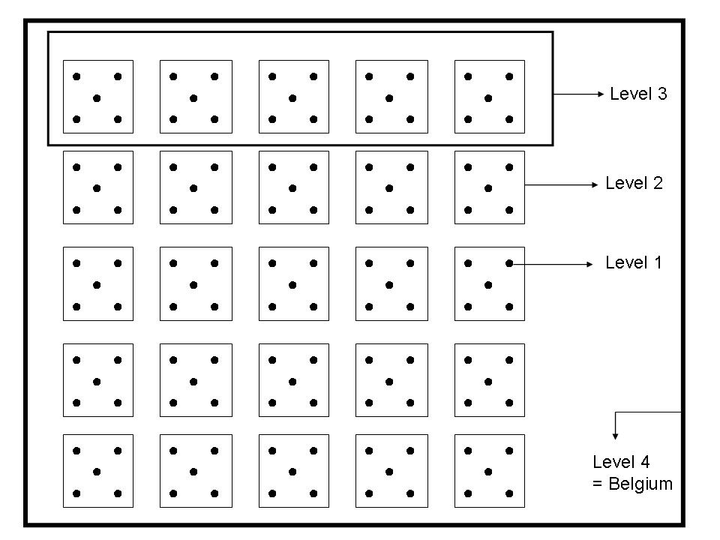
Figure 1: Schematic overview of the different levels of clustering applied within the multi-scale survey.

2.2. Detailed case study of a high density pond cluster

In the Tommelen bomb crater field (Hasselt) we will conduct a survey of the (semi-)permanent ponds (+/- 40; Fig. 2). These ponds will be sampled once in (early) summer 2007.

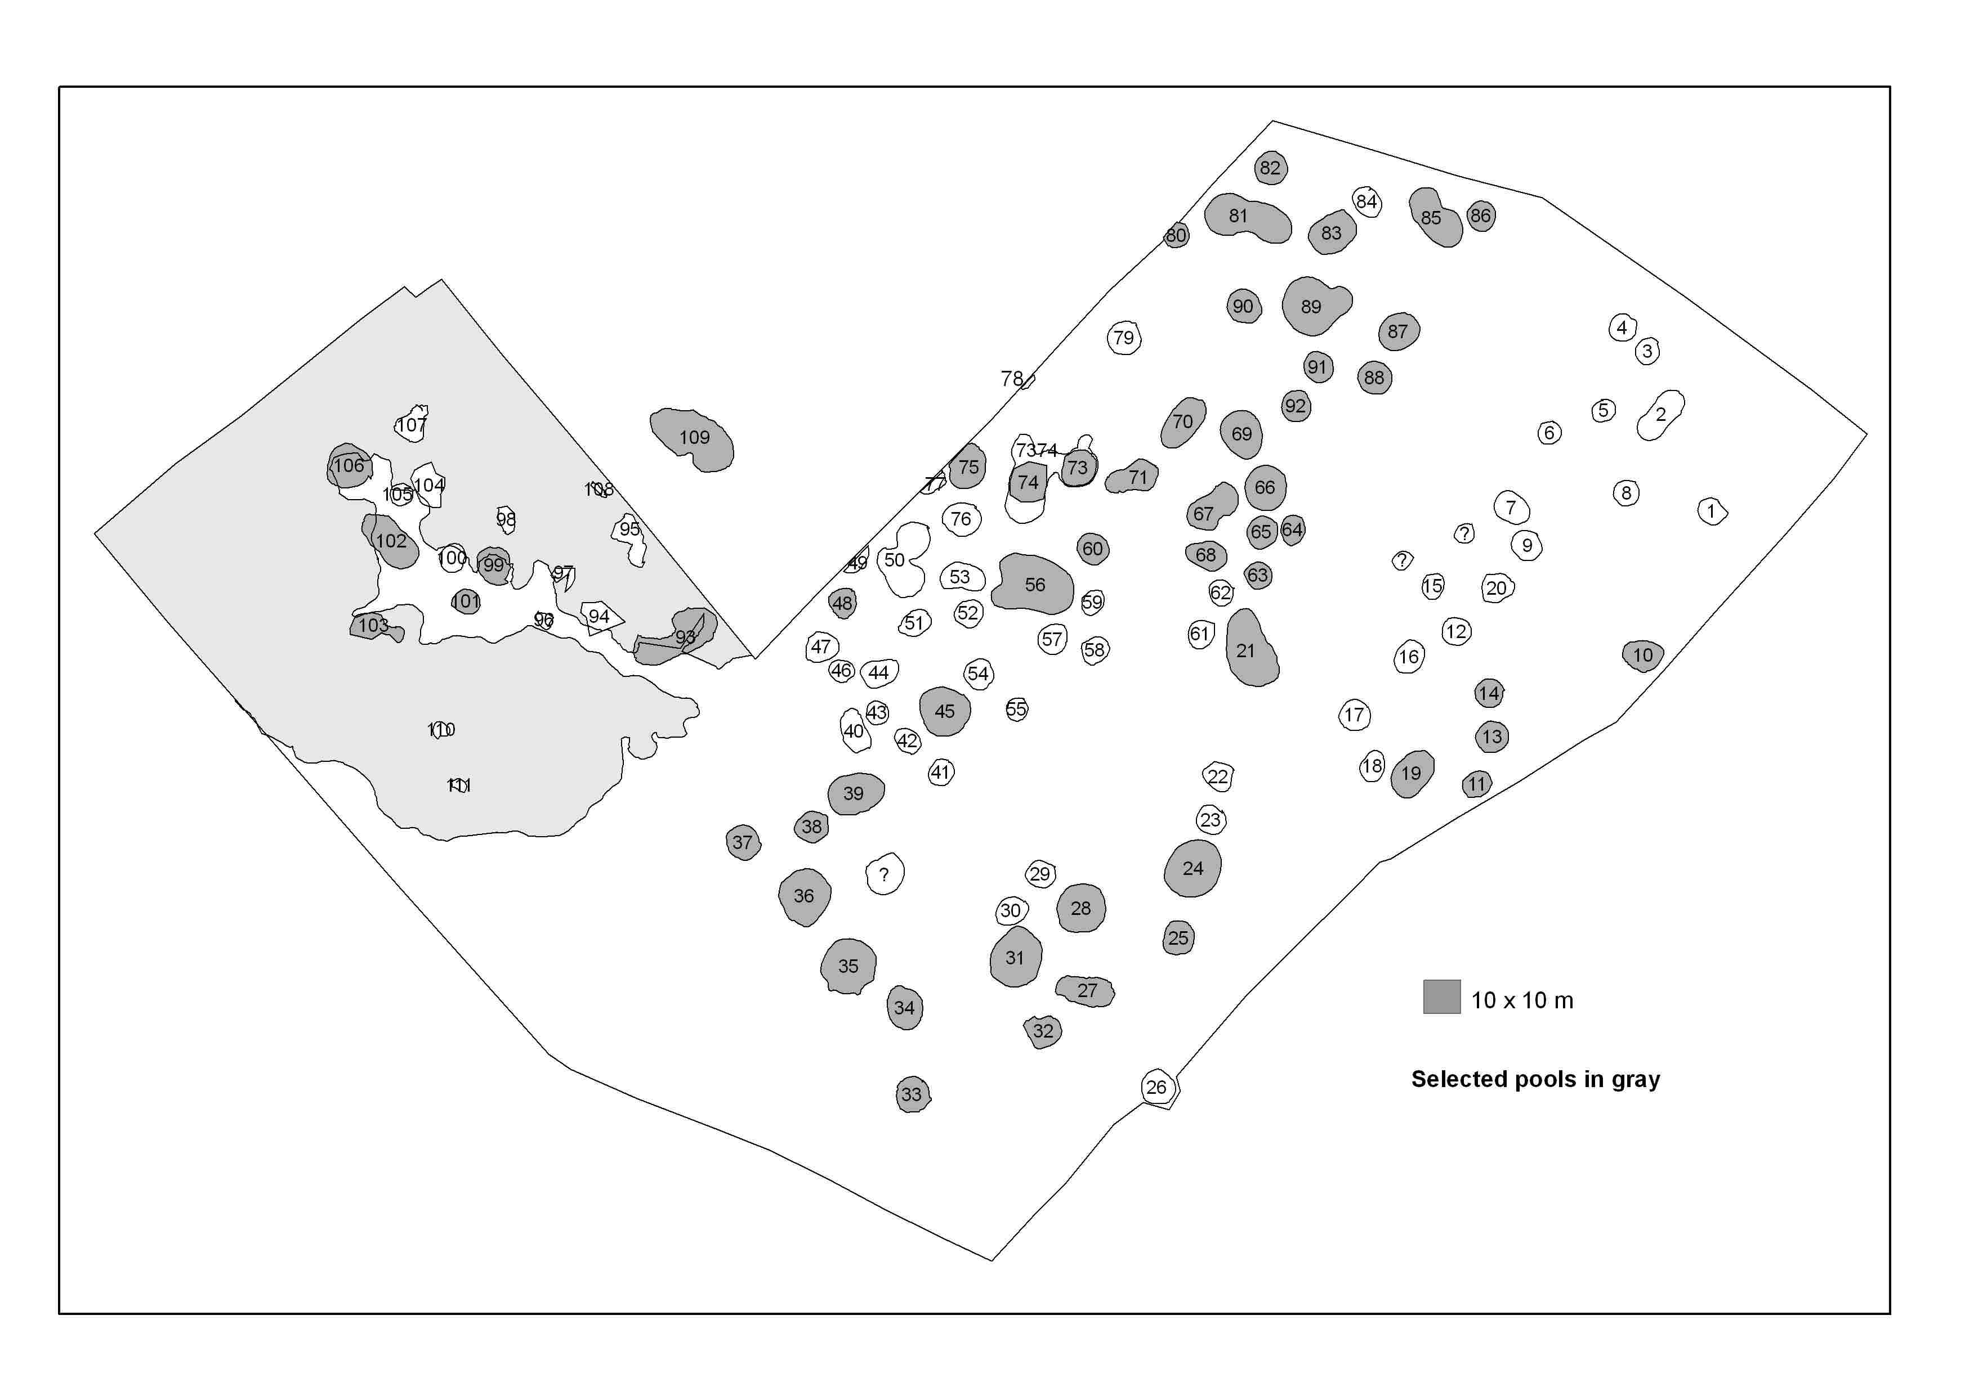
Figure 2: Overview of the selected ponds in Tommelen (Hasselt).

2.3. Evaluation of management techniques

In Tommelen we will select a number of ponds that will be managed. The selection will include ponds in the ‘impacted’ part of the bomb crater field and ponds in the ‘pristine’ part. We will sample the selected ponds before (as part of 2.2) and after the management activities. Management will take place in August 2008.

2.4. Evaluation of pollution

2.4.1. Dynamics in the pesticide loads

Water from fifteen small ponds (six in Flanders and nine in Walloon region) will be analysed for pesticides, and this three times in 2007: mid-April, end of June and mid-October. The sampling will be conducted in areas with intensive or extensive agricultural activities. Evaluation of the dynamics of problematic pesticides will be made in relation to the agricultural landuse level during the second year of the project.

2.4.2. Evaluation of pollution incidence by estrogen-like properties

Water will be sampled in all fifteen ponds already investigated for pesticide loads but also in some sewage treatment plant discharges in Wallonia as control samples.

2.4.3. Effects of pond management on the bio-availability of pollutants

Several ponds will be submitted to management actions. These will be sampled for water, sediments and fish before and after the actions for evaluation of changes in heavy metal loads and its eventual toxicity on aquatic organisms.

3. In the field

The protocol describes how the different organism groups of the studied ponds are sampled, how physico-chemistry and morphometry are assessed, and how background information is collected in a standardised way. All different organism groups described in the protocol will be sampled in the 125 ponds of the multi-scale survey (2.1), in the selected ponds in Tommelen (2.2) and in the ponds that will be managed (2.3).

3.1. Collection of background information

Sampling of a pond always started with the completion of a standardised form. This form should allow the standardized collection of important background information (see Annex I), including, type, age, state and management of the pond. Description of the area adjoining and within the radius of 500 m provides information about the presence of other water systems and the type of land surrounding the pond. Information on the flora of the immediate surroundings of the ponds and of its shoreline and macrophytes are provided. The shape of the pond is described as one or a combination of simple geometric figures (circle, square, oval) and the distances between specific locations are measured in order to be able to calculate the surface area. A drawing of the pond is made (see Annex II) and the section that has not been disturbed is indicated. Water depth along two perpendicular transects of the grid is measured (ca. every 2 m). The approximate height of the macrophyte vegetation at each of those locations is estimated (cfr. degree of infestation).

3.2. Collection of samples

3.2.1. Water (physical and chemical analyses, bacterio- and phytoplankton)

For suspended matter, chlorophyll a, pigments, chemical variables, bacterio- and phytoplankton, depth integrated water samples (in total 10 litres) are taken with a tube sampler at a central spot in the pond. In macrophyte-covered ponds, a water sample is taken in the middle of the largest open water patch without vegetation. The sample should be as clean as possible. Contact tube-sediment should be avoided at any time by sampling at least 20 cm above the sediment surface. If the sediment in the open water zone is covered with macrophytes, only water from the surface to 20 cm above the plants is used. The person that samples the pond should move very carefully and avoid sediment re-suspension as much as possible; the water sample should always be taken outside the cloud of re-suspended matter. If the pond is very shallow (< 20 cm), a 1 L-beaker can be used instead of a tube sampler to collect the water. The tube sampler or beaker is emptied very gently in a clean plastic bucket.

Treatment of the sampled pond water in the field: The water sample should be poured over a 250 µm mesh (to remove large organic material and invertebrates) in a very clean recipient, and different subsamples are taken (according to the order given below). Keep the bottles cool and dark during the remainder of the sampling day (cool box). The samples should be processed immediately upon arrival in the laboratory (see under).

Subsamples:
- Nutrients and ions: 5 bottles (210 ml) are filled, one for total phosphorus, one for total nitrogen, one for sulphates and chlorides, one for alkalinity and one for hardness (Ca²⁺ and Mg²⁺),
- Bacteria (quantitative sample): a 50 ml recipient is filled with a measuring cylinder and 1 ml of formalin (40 %) is added. This formalin has previously been filtered over a 0.2 µm pore size filter.
- Phytoplankton: a cubic container of 250 ml (VWR, ref. Kart 611, 0.87 € /p.) is filled with a measuring cylinder, and fixed with 1.25 ml acid lugol solution.
- Bacteria (qualitative): two litres of water are stored in a recipient
- Pigments, suspended matter: two litres of water are stored in a recipient

Measurement of physical variables: Conductivity and pH can be measured from a subsample of the water sample immediately after it has been taken. Temperature is measured in the water column of the pond at a depth of 20 cm. This is done after the water sample is taken, at a different location of the pond. Avoid to measure in clouds of suspended matter. Take care to rinse the electrodes after each measurement with Aquadest. The equipment has to be recalibrated every three days. Water transparency is to be measured with a Sneller’s tube (made in black material, length 60 cm, diameter 60 mm, white disc diameter 55 mm).

3.2.2. Zooplankton

3.2.2.1. Quantitative samples

Plankton is sampled with a tube sampler. A tube sampler allows efficient sampling of zooplankton both in the open water and in vegetation. At each of 8 locations, 6 litres of water are collected. The tube sample should integrate the entire water column (close to bottom), but bottom material should be avoided. The locations are selected using a predefined grid (Fig. 3). This grid assures that different subhabitats (shallow and deeper zone, different locations with respect to wind direction) are represented to a similar extent. On a sample location of the grid, the exact place to be sampled is chosen in a random way, irrespective of whether there are macrophytes or not.

SW
NE

Figure 3. Sampling locations situated in the pond

The water taken at the different locations is pooled in a big recipient (48L) after pouring it through a wide meshed screen (5 mm) to remove rubbish. After thorough stirring (8 standard mixing movements), subsamples are taken for:

Rotifera: volume of 6 L, filter through a 30 µm mesh, put in a 50 ml vial, and fix with lugol (4%, i.e. 2ml in recipient). If filtration for rotifers takes too much time, first filter through 100 µm and subsequently through 30 µm, and put both filters in the recipient. If filtration of 6 L is too time consuming (> 10 min), filter less volume but note the volume in the notebook and on the sample.
Crustacean zooplankton: Filter 40 L through a 64 µm conical net, collect the sample in 50 ml vial, fix with lugol (4%, i.e. 2 ml in recipient).

If there is too much of organic material and the lugol is absorbed, the zooplankton samples (rotifers and crustaceans) should be fixed with sugar-saturated formalin.

3.2.2.2. Qualitative

A sweep net sample (64 µm) for the assessment of zooplankton taxon richness is taken, incorporating both pelagic and macrophyte habitats. The absolute time of sweeping should not necessarily be the same in each pond, but should depend on pond size and habitat complexity: sweep time should be approximately allocated in proportion to the relative importance of different types of habitats (pelagic, different types of depths and macrophyte species), following the same scheme as above. Try to sample as many subhabitats as possible (in case of dense macrophyte vegetation: shake the plants in the net. The sample for taxon richness analysis should be fixed with sugar + formalin (2 ml in 48 ml of sample).

3.2.3. Phytobenthos

3.2.3.1. Pigments

The benthic water layer is sampled with a plexiglass corer (3 cm diameter), which is pushed into the substratum on 1 location in the littoral zone (for standardisation always at a depth of 20 cm). The excess water atop is removed with a pipette and the first millimetres of sediment of each core are sliced off and gathered in one 100 ml bottle (ref. see nutrients) until a volume of 5 ml is reached. Take care to exclude parts of macrophytes (remove with tweezers). These samples are kept cold in the dark during transportation and stocked in the deep freeze (preferably -80 °C) until pigment analysis.

3.2.3.2. Diatoms

Single samples of the superficial 2-3 mm of sediment are collected in the deepest part of each pool by means of a transparent coring tube (internal diameter 36 mm) and preserved immediately with formaldehyde.

3.2.4. Zoobenthos

Zoobenthos is sampled quantitatively by means of a handcorer (Ø 52 mm). In each pool eight sample units are taken, according to the grid (Figure 1), but at undisturbed locations. The sampling units should reflect the actual variation in soil structure, vegetated areas and depth. The upper 10 cm of the soil and the water layer of these eight sample units are pooled in a bucket. Before fixation the sample is firmly stirred. Then, it is transferred to a 5 litre container containing the paraformaldehyde solution (6 % minimum) and sodium carbonate (75 g). Sodium carbonate is necessary to prevent decalcification of the organisms.

3.2.5. Fish

The Point Abundance Sampling (P.A.S.) is used. It is an electrical fishing suitable for small juvenile fish (minimal size: 6 to 7 mm) in small water bodies such as ponds. Several sampling points are made depending on the surface area of the considered pond and the abundance of each capture (6 to 8 anode immersions per acre). The anode is immerged at random locations within the pond. At each location, fish are collected with a handnet.

3.2.6. Snails (and parasites)

Snails are collected manually during a 15 minutes time period. Two species are collected: Lymnaea truncatula (for parasitic load determination) and L. stagnalis (for PCB’s detection and as internal negative control for trematode infection). Lymnaea stagnalis is bigger than L. truncatula. The two species (up to 50 individuals for each species if possible) are collected into 2 separate tubes containing some water from the pond. The search for snails should not only be in the water, but also on emergent and littoral vegetation.

3.2.7. Macro-invertebrates
A qualitative investigation is made in the open water area and the macrophyte covered areas. The samples are taken with sweep-net (mesh size: 250 µm). In each pool, sweep-net sampling is conducted by striking the net in the open water area, among the submerged macrophytes, floating-leaved macrophytes and in the reed bed. The time spent in each vegetation type or in the open water area is adapted to the estimated percentage covered in the pool. Sampling time per pool is adapted according to pool size. Sampling is conducted by walking around the area and should include the whole water column. After sweeping with the net at the different sampling stations, all material is pooled. To include species, which are attached to a substratum, different kinds of aquatic vegetation and substrata are stirred off in the net and added to the sample. Macro-invertebrates are fixated in 1 litre of water containing paraformaldehyde (6% minimum) and sodium carbonate (15 g).
The pool bottom is sampled by scraping a surface area of 0.2 m² in a vegetation free area. The soil is washed from the net and larger macro-invertebrates and a piece of washed soil are collected manually. The water column is sampled in the open water area (1000 cm²) and vegetation covered area (5-10 % of the vegetation). The three sub-samples are pooled in a 250 ml container and fixated in 100 ml borax saturated ethanol (70 %).

3.2.8. Amphibians

During the multi-scale survey campaign in summer, amphibians that are accidentally caught in handnets are identified, counted and released. For certain tasks (e.g. Task 1.4), additional sampling of amphibians is performed using standard techniques, including: dip-netting, placing funnel traps for the night, and visual (and auditory) observation of adult animals, larvae and egg clumps or strings. Species, number of individuals, life stages and gender are recorded. Species identification is performed on live specimens using standard keys. Dip-netting is performed using dip-nets with an effective surface of ca. 10 dm² and a mesh-width of 4 mm. The amount of time dedicated to sampling is set proportional to the surface area of the studied water body.

During the survey of the ponds of Tommelen, we will apply two different sampling techniques:

Fyke sampling (mainly adult newts): In each pond two fykes are placed, preferable on the South oriented shore. These are the optimal shores for the mating ritual of newts. Fykes are placed in the morning and checked the next morning. The opening is aimed at the center of the pond with the top of the cage 5 till 10 cm above the water surface. Results are expressed in number of individuals per species per fyke.

Sweepnet sampling (juveniles): Ponds are sampled several times for macro-invertebrates. Amphibians present in these samples are counted and released in the ponds. Additional sweepnet samples are taken for amphibians. Every 1.5 m of shoreline the net is swept over the bottom of the pond from the center towards the shore. Present amphibians are counted and released. Numbers of individuals per species per sweep are recorded in situ.

3.2.9. Phanerogams

Macrophytes (submerged, floating and emergent) and helophytes are identified on the site. Critical species that need more intense examination for correct identification are sampled, dried and studied in the laboratory. The dominance and/or frequency of the phanerogamic plants are estimated in the field (Braun-Blanquet scale modified by Barkman et al. 1964), at least for those in the submerged parts of the ponds. The central (always submerged) part and the vegetation near the shoreline (shallow water with presence of hydrophytes and helophytes) are treated separately and their relative cover (percentage) estimated. In the emerged part of the shoreline (consisting mostly of helophytes) a wet and a dry zone are described separately, the wetter part often being submerged during winter and early spring. In those parts and in the surrounding area around the ponds the frequency and importance of the different plant species were roughly estimated (Tansley-code).

3.2.10. Microbes (ecosystem functioning)

Water samples used for the determination of microbial functionalities (primary production, bacterial secondary production, nitrification rate, community-level physiological profiling (CLPP), microbial respiration) are taken in a similar way to suspended matter, chlorophyll a, pigments, chemical variables, bacterio- and phytoplankton. Depth integrated water samples (in total 10 litres) are taken with a tube sampler at a central spot in the pond. In macrophyte-covered ponds, a water sample is taken in the middle of the largest open water patch without vegetation. The sample should not contain sediments. These samples are stored in autoclaved glass bottles until analysis. The bottles are completely filled with water, closed and placed in iceboxes filled with pond water in order to keep the sampled water at in situ temperature. Incubations of the microbial communities in the presence of radiolabelled substrates (primary production, bacterial secondary production, nitrification rate), in Winkler bottles for respiration and in microplates for CLPP must be started within one hour after collection.

3.2.11. Sequence of work

Before main sampling campaign:
Ecosystem functioning (microbial community)
Macrophytes (+ collection material)

Main sampling campaign:
1 | Completion of form with background information, pictures
2 | Water samples
3 | Physical variables (Secchi, Sneller, pH, conductivity,…)
4 | Plankton tube sampling + treatments
5 | Phytobenthos/zoobenthos
6 | Zooplankton/macro-invertebrates sweepnet sampling
7 | Fish and amphibians
8 | Snails
9 | Morphometry

General remarks:

Contamination between ponds should be avoided at any time. All equipment should be thoroughly rinsed between sampling of two different ponds!

Exposure of the samples to direct sunlight should be avoided during sampling, transportation and filtration. In the field, samples should be kept in a cool box with ice.

A list with the material needed for the sampling is provided in Annex II.

4. In the laboratory

Water samples should be appropriately treated immediately upon arrival in the laboratory. The samples collected for different organism groups (bacteria, phytoplankton, phytobenthos, zooplankton, zoobenthos, macro-invertebrates and water plants) are analysed with the aim of characterising community structure, taxonomic composition and diversity. These analyses are done in a standardized way, with the objective to maximally guarantee the compatibility of the different datasets. The methods that are applied, nevertheless, also depend on the organism group under consideration: (1) samples of bacteria are screened with molecular methods (Denaturing Gradient Gel Electrophoresis), (2) the analyses of the phytoplankton and phytobenthos communities are based on pigment analysis and (3) samples of zooplankton, zoobenthos and macro-invertebrates are analysed using conventional methods, following an approach based on counts and taxonomic identifications. The latter analyses yield quantitative information on the absolute and relative abundance of taxa.

4.1. Water

- Pigments: A known volume (depending on the turbidity) of the ‘water sample’ is filtered over a glass fibre filter (Whattman GF/F, diameter 47 mm). The filter is folded in two and dried a little bit with Kleenex. This filter is wrapped in aluminium foil, labelled and stored in the freezer (-80 °C) until pigment analysis.
- Bacteria (qualitative: for DGGE): Two filters per pond have to be prepared (one as backup). For each filter, pool water (1 L) from the ‘water sample’ is first poured over a screen of 20 µm to remove particles. Two volumes of 250 ml are filtered over a 0.2 µm MF-Millipore MCE filter (Millipore catalogue #: GSWP02500) using a syringe with syringe filter holder (Fig. 4). In case the filter gets clogged and no 250 ml can be filtered, the volume that has been filtered should be noted! Each filter is placed on a separate, square piece of aluminium foil and folded twice. Then only the open edges of the aluminium foil packages are folded so leakage is prevented. Finally, the aluminium foil packages are labelled properly (Fig. 5). Store the filter at < -20 °C (preferably –80 °C) until shipping.

General remarks:
  - Take care of contamination! Since we amplify DNA by PCR, it is very important that there is no inter-pond contamination. A small amount of bugs from group X in pond A may be transferred to the next pond B via the tubes and vessels used. If this group is not represented in pond B, it may thus turn up and give a false positive result. Therefore, take care to start with clean equipment and rinse equipment between lakes using lake water. There is no necessity to rinse between sample sites for the pooled sample.
  - Clean-start and in between rinsing goes for: sample tubes, plankton nets and containers (pond container, volume measuring containers etc) in which material for DNA analysis goes. Do not use ethanol.

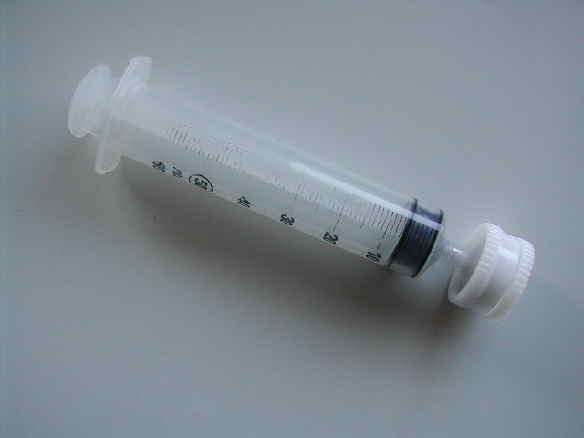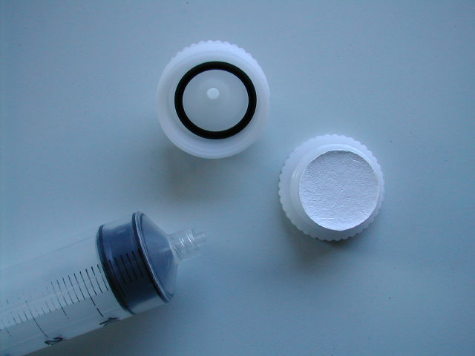
Figure 4: Pictures of syringe with filter holder

Aluminum foil
First fold line
Second fold line
Fold edges
label
Microorganisms – DNA
Pond n°:
Date: Year:
Volume filtered:
Label

Figure 5: Schematic overview of folding procedure

- Suspended matter: Filter as much water as possible from the ‘water sample’ over a pre-weighted glass fibre filter (dried at 105 °C during 24 hours, and weighted, after cooling down in an exicator; Whattman GF/F, diam. 47 mm) with a vacuum pump. The volume of water that has been filtered should be noted. This filter is wrapped in aluminium foil, labelled and stored in the deep freezer (-20 or -80 °C) until analysis. When all the ponds are sampled, these filters are dried again at 105 °C during 24 hours and the weights are measured. The difference is the amount of suspended matter.
- Total P and N: No filtration is needed. The two bottles are stored in a deep freezer (-20 °C) until analysis. Total nitrogen in the water is determined by using standard Kjeldahl method (Hach, 1997). To determine the total phosphate in the ponds HClO₄ reagent is used (Golterman & Clymo, 1968).
- Alkalinity, sulphates and chlorides: The water sample for sulphates and chlorides, and the alkalinity sample are stored at 4 °C until measurements are carried out by standardised methods following the Hach Water Analysis Handbook (1982). Turbidimetric method using Sulfa Ver 4 sulphate reagent determines the sulphate concentration in the water. Chloride concentration is measured by the Mohr Argentometric Method. Alkalinity is determined following a titration method.
- Hardness: The hardness sample is placed in the deep freezer (- 20 °C) until the analysis. Total hardness is measured by titration using Man Ver 2 Hardness Reagent.
- Heavy metals: The 2 L sample (cf. 3.2.2) is filtered through a 125 μm mesh screen for large organic particles, and then filtered over a 1.2 µm Teflon filter. The filter is previously cleaned with HNO₃ 10 %. The filter is labelled and stored (15-20 °C) in a dark box for determination of heavy metals in phytoplankton. 50 ml of the filtrate is stored (in plastic matter) for determination of heavy metals in water.

4.2. Bacteria

To assess numerical diversity and composition of the bacterial community, Denaturing Gradient Gel Electrophoresis (DGGE) techniques are applied. This involves 6 steps:

- Collection of bacteria by filtration
- Isolation of total community DNA
- Use of this DNA as a template for PCR amplification (16SrDNA: 338-538 bp)
- DGGE
- Sequencing of DNA from DGGE band
- Estimates of species diversity (presence and relative abundance of different species)

In order to obtain information on total bacterial biomass in the different ponds studied, bacteria are enumerated using epifluorescence microscopy (Hobbie et al. 1977). For enumeration of bacteria from the water samples collected and fixed with formalin, a known volume of these samples is stained with DAPI at a final concentration of 2 µg ml⁻¹ and is filtered onto 0.2 µm pore size membrane filters. At least 400 cells are counted in at least 5 fields under UV illumination.

4.3. Phytoplankton and phytobenthos

Phytoplankton and phytobenthos are monitored using HPLC pigment analysis of seston collected on glassfibre filters and surface sediment samples, respectively. In addition, samples fixed with lugol can be analysed for species composition of the dominant taxa.

4.3.1. Phytoplankton

For the analysis of phytoplankton, a known volume of water is filtered onto a GF/F filter, 47 mm. This filter is dried between blotting paper to remove excess water. Then the dried filter is immediately wrapped in aluminium foil and stored at -80 °C. Pigments are extracted in 2 ml of a 90 % acetone solution in a dark room and sonicated during 30 s.

4.3.2. Phytobenthos

- Pigments: For the analysis of phytobenthos pigments, 1 ml sediment is freeze-dried in an aluminium container during 3-4 hours. The weight is measured and pigments are extracted in 10 ml 90 % acetone solution and sonicated. The extracts are filtered over a 0.2 µm pore size filter to remove small particulates. Pigment extracts are analysed by means of HPLC, according to the method of Wright et al. (1991). A chromatogram is obtained on which peaks of phytoplankton pigments can be observed. While chlorophyll a concentration is used as a measure for total phytoplankton and phytobenthos biomass, group-specific marker pigment concentrations are used to determine the relative contribution of the major algal groups to total phytoplankton and -benthos biomass. The pigment concentration is determined by the previous calibration of each pigment and the integration of the peak area. Data are analysed using the CHEMTAX program and multiple regression techniques.
- Diatoms: Sample preparation followed standard procedures for removing organic matter by hydrogen peroxide treatment and carbonates. Permanent slides were made using Naphrax and examined by interference light microscopy at appropriate magnification (Olympus BX50 and BX51 microscopes). Selected taxa were documented by digital photography. Identifications are based mainly on standard floras and recent monographs.

4.4. Zooplankton

From each quantitative sample, the total population densities of anostracans, copepods, rotifers and cladocerans are determined. For cladocerans, more elaborate counts are carried out in order to obtain detailed data on taxonomic composition and species richness. A pilot study is conducted to find out what type of sample (e.g. quantitative or qualitative) is most appropriate for the study of diversity. For each pond in each season, 300 cladoceran individuals are identified to the species level. Identifications are done using the identification key of Flößner (2000).

4.5. Zoobenthos

For each pond, the total population density of the major zoobenthic groups is determined. Quantitative core samples are washed through a conic net (mesh size 250 µm) to remove the sediment and reduce the size of the samples. Further, samples are sieved again on a sieve of 500 µm and kept in a recipient. The part of the sample retained on the sieve of 500 µm is sorted. All macro-invertebrates are picked out and stored in alcohol (70 % of ethanol + borax). For the identification of the different groups standard identification keys are used (see 4.1.5).

4.6. Macro-invertebrates
The relative abundance of the major macro-invertebrate groups is estimated from the sweepnet samples. The qualitative samples taken by sweepnet sampling are subsampled. 1/8 of a total sample (sieved on 250 µm) is sorted and all macro-invertebrates (additionally Ostracoda) are picked out. From the 7/8 of a qualitative sample (sieved on 500 µm) individuals larger than 500 µm (excluding Ostracoda) are picked out.

List of identification keys:
General: De Pauw & Vannevel (1991)
Coleoptera: Drost & Vannevel (1978), Drost et al. (1992)
Mollusca: Janssen & Vogel (1965)
Ostracoda: Meisch (2000)
Chironomidae: Cranston (1982), Wiederholm (1983), Moller Pillot (1984), Wilson (1996)
Hemiptera: Niesser (1974), Savage (1989)

4.7. Amphibia

Species identification is performed on live animals using standard keys. If the in situ identification of the larvae of some species is difficult, a small sample (n = 5) of individuals is collected for the identification in the laboratory (identification key: Lenders & Marijnissen, 1993)

4.8. Water plants

The collected water plants are identified up to the species level if possible (Weeda et al., 1994; Van der Meijden 1996; Stace 1997; Lambinon et al. 1998).

4.9. Microbes

Microbes are isolated from the larger organisms (zooplankton, insects) by filtration of the water on a Nylon plankton net with a mesh size of 40 µm. Filamentous algae are thus excluded from the samples.

Primary production is determined using NaH¹⁴CO₃ as tracer according to Colijn & Edler (1999). Fifty ml subsamples taken directly from the glass bottles are incubated during two hours in the presence of NaH¹⁴CO₃ (Amersham, 10 µCi.50 ml-1) in an ICES incubator (Hydro-Bios GmbH, # 450 000). The maximum irradiance value is 500 µE.m⁻².s⁻¹. Neutral grey filters are placed on the subsamples to attenuate the irradiance (69.3 %, 51.2 %, 23.5 %, 13.7 % and 6.6 %, respectively). At the end of the incubation, subsamples are filtered on cellulose acetate membrane (porosity = 0.2 µm). Filters are placed in a scintillation vial and dissolved with 1 mL of ethyl acetate. The radioactivity of the vials is measured using the “Filter-count” scintillation cocktail (Perkin-Elmer) and a Packard Tri-Carb 2900 TR liquid scintillation counter. Simultaneously to the primary production, chlorophyll a is determined by the monochromatic method (Lorenzen, 1967).

In the black flasks (transmission level = 0%), NaH¹⁴CO₃ can be assimilated by sulphur, iron, nitrifying and hydrogenotrophic methanotrophic organisms. The assimilation rate of NaH¹⁴CO₃ in the dark flaks corresponds to the total lithoautotrophic activity. Inhibitors of the nitrification (allylthiourea, 10 mg.l⁻¹ + sodium chlorate, 10 mM) can therefore used in order to discriminate the nitrifying activities from the total lithoautotrophic activities (Brion & Billen, 1998). Replicates of black flasks are incubated with and without inhibitors during 24 hours at in situ temperature in dark in order to quantify the nitrification activity of the sampled water.

Bacteria secondary production was measured according to the “microcentrifuge method” described by Kirchman (2001). Briefly, 1.7 ml of the pond water were incubated in the presence of [2,3,4-3H-leucine] (Amersham) in 2-ml centrifuge tubes for 2 hours. Increasing concentrations of added leucine from 5 nM to 80 nM were used (triplicates plus two blanks) in order to estimate the isotopic dilution. The incubation was stopped by the addition of Trichloroacetic acid (TCA, 100% w/v). Stopped samples were stored at 4°C until centrifugation. Pellets containing bacteria were recovered after centrifugation and washing in ethanol. The radioactivity of the pellets was determined using the “Ultima-Gold” scintillation cocktail (Perkin-Elmer) and a Packard Tri-Carb 2900 TR liquid scintillation counter. The incubations were performed in Memmert incubators at 20°C. Simultaneously to the incubations, a subsample of water was preserved in formaldehyde (2% final concentration) for the enumeration of the bacteria using Sybr Green I as staining agent.

The respiration of the microbial community (with a size lower than 40 µm) is determined by assessing the consumption of dissolved oxygen during 24 hours in the dark at 20 °C. The oxygen concentration is determined by the iodometric method (http://www.standardmethods.org) using a Schott Titroline alpha microtitrator. When the oxygen concentration is lower than 4 mg O₂.L-1, the incubation was limited to 8 hours.

Community Level Physiological Profiling is carried out using the Ecolog plates produced by BIOLOG® (Garland, 1997). These plates contain 31 carbon sources coated in triplicates in 96-well plates. Purple colour is developed in the wells when the microbes use the carbon source. Colour formation is monitored during 7 days using a BIORAD Microplate reader. The incubations are performed in Memmert incubators at 20 °C. Measurement are stopped when the optical density reaches 2. The data will be analysed using Principal Component Analysis or an equivalent ordination technique (eg: MDS).

4.10. Parasites

4.10.1. Intermediate host: Snails

The snails collected from the different plots were frozen at –80 °C until their use for the molecular biology assay.

- DNA extraction: The snail shells are crushed and removed. Intact tissues from snails are rinsed once in DNA extraction buffer, placed in a microcentrifuge tube with 400 µl of extraction buffer and crushed with a polypropylene pestle. DNA from snails is then extracted according to the phenol-chloroform method. Two steps are followed: in the first, an equal volume of phenol-chloroform-isoamyl alcohol (25/24/1) is used, the phases are separated by centrifugation at 12000 rpm for 10 min; in the second, the aqueous phase is mixed with an equal volume of chloroform-isoamyl alcohol (24/1). Another centrifugation at 12000 rpm for 10 min is performed. The aqueous phase finally obtained is precipitated with 1/10 volume of 3 M sodium acetate and 2.5 volume of absolute ethanol cooled at –20 °C, and refrigerated at –20 °C for 1 h. The pellet obtained after centrifugation at 12000 rpm for 30 min is washed in 75 % ethanol, centrifuged at 12000 rpm for 10 min at 4 °C, and briefly air-dried (inverting the tube on a paper towel). The precipitated DNA is redissolved in a small volume of TE buffer (10 mM Tris-HCl, pH 7.6; 1 mM EDTA). DNA is stored at –20 °C until subsequent use.
- Detection of infected snails: For the detection of infected snails, a specific repetitive probe of Fasciola hepatica is used. DNA extracted from snails is excised by digestion with a restriction enzyme and DNA fragments are separated by agarose gel electrophoresis. DNA fragments are transferred from the gel to a nylon membrane. The membrane is prepared in prehybridisation solution and the radiolabeled probe DNA of F. hepatica is added in the solution for overnight hybridisation. Hybridising clones are identified by autoradiography.
- Laboratory infection of snails: The eggs are poured in a falcon and put in an incubator (22 °C) for 14 days for embryonation. The emergence of miracidia is induced by cooling on an ice bath and lighting. Eggs hatch within 1 hour. For collecting the miracidia, they are transferred to a small opaque Earlen mayer with a small window at the top. A source of light is placed behind that. Miracidia are gathering at the window level. The counting of miracidia is performed in a Petri dish under a binocular microscope. Snails are infected with five miracidia each. The snails/miracidia are left overnight. After 1 night the infected snails are transferred to fresh culture dishes. The infected snails are used as a positive control for the presence of Fasciola hepatica. As a negative control, Limnea stagnalis DNA is used.

4.10.2. Final host: Cattle

- Preparation of somatic Fasciola hepatica antigen (FhSomAg): Freshly collected adult flukes are washed in phosphate buffered saline (PBS 0.05 M) and homogenized in a ten Broeck tissue grinder at 4 °C. After centrifugation (12000 rpm for 30 min at 4 °C), the supernatant is collected and referred to as FhSomAg. Protein concentration is measured by the bicinchoninic acid method. FhSomAg is stored at –80 °C until required.
- Enzyme-linked immunosorbent assay (ELISA): Blood samples are centrifuged and the sera collected. Microplates are coated with 100 µl per well of FhSomAg (10 µg/ml) diluted in PBS, then left overnight at room temperature. After 3 washes with PBS-Tween 0.05 %, plates are saturated with 10 % horse serum in PBS and left overnight at room temperature. Sera are diluted at 1/100 in a casein hydrolysate dilution buffer. All sera are tested in duplicate. The plate are incubated for 90 min at room temperature and then washed five times in PBS-T 0.05 %. Mouse monoclonal anti-bovine conjugated to horseradish peroxidase is added at a dilution of 1/125000 for another 90 min. After 3 washes in PBS T, the substrate (3,3’-5,5’-tetramethyl-benzidine prepared in citrate buffer pH 4.2 with 1.5 µl/ml H₂O₂) is added. The reaction is stopped after 10 min with 50 µl of 1 N sulfuric acid. Optical densities are read at 450 nm with a microplate autoreader.

4.11. PCB’s

PCB levels are determined in snail (Lymnaea truncatula and L. stagnalis) homogenates. PCBs are analysed by a high performance gas chromatographic method. The homogenate sample is lyophilised before a first lipid extraction by an accelerated solvent extractor. Then, the lyophilised extract is purified by a first acid cleaning-up to eliminate all the organic matters (residuals lipids, lipoproteins, carbon hydrates, etc), and a second florisil cleaning-up for the most polar molecules. Then, the amount of total PCBs in the purified extract is determined by chromatography and the different PCB isoforms are separated by increasing progressively the temperature.

4.12. Heavy metals

Heavy metal determinations in fish and/or snails are performed by different mass spectrometric methods using a HR-ICP-MS integrated system. The snail or fish homogenates are digested before analyses. The sample is converted in aerosol form, which is introduced in a plasma (a high temperature chamber at 8000 °C) for ionisation, and then it is possible to identify and quantify each ion according to its mass and intensity. The following heavy metals are determined: Cu, Sn, Zn, Cd and Pb.

4.13. Pesticides

Triazines, diuron and isoproturon will be assayed by high performance liquid chromatographic (HPLC) methods after filtrations and solid-phase extraction (SPE). Extraction process and HPLC column characterization have been standardized last year in our laboratory. The analysis of glyphosate and its surfactant needs a standardization phase because the available attempts to evaluate the load of this pesticide in environmental samples failed to provide accurate results by HPLC methods due to its low molecular mass and high polarity. Therefore, the standardization step will combine HPLC and mass spectrophotometric methods.

4.14. Oestrogen-like properties

After micro-filtrations and SPE extraction, estrogen-like properties in water samples will be revealed by MCF-7 cell proliferation assay E-screen. This method is now found more accurate for xeno-estrogenic contamination in environmental samples than the YES screen test for which we did not find reagents. The first step of this E-screen method is the cell proliferation by seeding the MCF-7 cells on a black 96-well microtiter plate after removal of all estrogenic compounds. Cells are incubated for 72 h. As a second step, cells are exposed to extract samples including standard solutions containing different levels of estrogen. Then the cells are incubated at 37 °C, and on the sixth day of incubation, the physiological responses are determined by cell proliferation analysis using flow cytometric methods. Additionally, we will determine in vivo concentrations of estrogen-like properties. For this, we will collect in a selection of ponds 5 to 10 fish between April and May 2008 to compare the in vitro estrogenic activity to in vivo responses by assessing vitellogenin induction (ELISA) and aromatase activity (radioimmunoassay).

Reference list

Barkman, J.J., Doing, H. & Segal, S. 1964. Kritische Bemerkungen und Vorschlage zur quantitativen Vegetationsanalyse. Acta Bot. Neerl. 13: 394-419.

Brion, N. & Billen, G. (1998) Une réévaluation de la méthode d'incorporation de H¹⁴CO₃ pour mesurer la nitrification autotrophe et son application pour estimer des biomasses de bactéries nitrifiante^{s}. Revue des Sciences de l'Eau 11: 283-302.

Colijn, F. & Edler, L. 1999. Working manual and supporting papers on the use of standardized incubator-technique in primary production measurements. http://sea.helcom.fi/monas

Cranston, P.S. 1982. A key to the larvae of the British Orthocladiinae (Chironomidae). Freshwater Biol. Ass. No. 45.

De Pauw, N. & Vannevel, R. 1991. Macro-invertebraten en Waterkwaliteit. Stichting Leefmilieu, Antwerpen.

Desmarais, K.H. 1996. Keeping Daphnia out of the surface film with cetyl alcohol. J. Plankton Res. 19: 149-154.

Drost, B. & Schreijer M. 1978. Waterkevertabel. Jeugdbondsuitgeverij, Amsterdam

Drost, B., Cuppen, H.P.J.J., Van Nieukerken, E.J. & Schreijer, M. 1992. De waterkevers van Nederland. Stichting Uitgeverij Koninklijke Nederlandse Natuurhistorische Vereniging, Utrecht.

Flößner, D. 2000. Die Haplopoda und Cladocera (ohne Bosminidae) Mitteleuropas. Backhuys Publishers, Leiden, The Netherlands. 428pp.

Garland, J.L. 1997. Analysis and interpretation of community-level physiological profiles in microbial ecology. FEMS Microbiol. Ecol. 24: 289-300.

Golterman, H.L. & Clymo, R.S. 1968. Methods for chemical analysis of fresh water. p. 74-76. IBP Handbook No 8., Blackwell Scientific Publications, Oxford and Edinburgh. pp. 172.

Hach. 1997. Hach Water Analysis Handbook, 3rd ed., Hach Company, Loveland, CO.

Haney, J.F. & Hall, D.J. 1973. Sugar-coated Daphnia: a preservation technique for Cladocera. Limnol. Oceanogr. 18: 331-333.

Hobbie, J.E., Daley, R. & Jasper, S. 1977. Use of Nuclepore filters for counting bacteria by fluorescence microscopy. Applied and Environmental Microbiology 33: 1225-1230.

Janssen, A.W. & Vogel, E.F. 1965. Zoetwatermollusken van Nederland. Nederlandse Jeugdbond voor Natuurstudie, Amsterdam.

Kirchmann, D., 2001. Measuring bacterial biomass production and growth rates from leucine incorporation in natural aquatic environments. Methods in Microbiology 30: 227-237.

Lambinon, J., De Langhe, J.E., Delvosalle, L. & Duvigneaud, J. 1998. Flora van België, het Groothertogdom Luxemburg, Noord-Frankrijk en de aangrenzende streken. Nationale Plantentuin, Meise. 3de druk, pp. 1091.

Lenders, H.J.R & Marijnissen, C.C.H. 1993. Waarnemen en herkennen van amfibieën en reptielen in het veld. RAVON, Nijmegen.

Lorenzen, C.J. 1967. Determination of chlorophyll and phaeopigments. Spectrophotometric equations. Limnol. Oceanogr. 12: 343–346

Meisch, C. 2000. Freshwater Ostracoda of Western and Central Europe. Spektrum Academischer Verlag, Heidelberg, Berlin.

Moller Pillot, H.K.M. 1984. De larven der Nederlandse Chironomidae (Diptera). Vol.1-2. Rijksmuseum van Natuurlijke Historie, Leiden, Nederland.

Newton, C.R. & Graham, A. 1994. PCR, introduction to biotechniques. BIOS Scientific Publishers Limited. pp 161.

Nieser, N. 1974. De Nederlandse water- en oppervlaktewantsen. Zoologisch Laboratorium, afd. Systematiek, Utrecht

Platt, T., Galegos C. L. & Harrison W. G. 1980. Photo-inhibition of photosynthesis in natural assemblage of marine phytoplankton. J. mar. Res. 38: 687-701.

Savage A. A. 1989. Adults of the British aquatic Hemiptera Heteroptera. Freshwater Biol. Ass. No. 50.

Stace, C. 1997. New Flora of the British Isles. 2nd ed. Cambridge University Press, pp.130.

Steeman Nielsen, E. 1952. The use of radioactive carbon (¹⁴C)for measuring organic production in the sea. J. Cons. Int. Explor. Mer 18: 117-140.

Van der Meijden, R. 1996. Heukels' Flora van Nederland. Wolters-Noordhoff, Groningen, 22e druk, pp. 678.

Vollenweider R.A. 1965. Calculation models of photosynthesis depth curves and some implications regarding day rate estimates in primary production. Memorie dell’Istituto Italiano di Idrobiologia 18: suppl. 425-457.

Weeda, E.J., Westra, R., Westra, Ch. & Westra, T. 1994. Nederlandse Oecologische Flora: wilde planten en hun relaties. Vooral deel 5. Amsterdam, Uitgegeven in samenwerking met de VARA en de Verenig. Natuurmonumenten. pp. 400.

Wiederholm, T. 1983. Chironomidae of the Holarctic region. Borgstroms Tryckeri AB, Motala.

Wilson, R.S. 1996. A practical key to the genera of pupal exuvia of the British Chironomidae (Diptera: Insecta). Country Print.

Wright, S.W., Jeffrey, S.W., Mantoura, R.F.C., Llewellyn, C.A., Bjornland, T., Repeat, D. & Welshmeyer, N. 1991. Improved HPLC method for the analysis of chlorophylls and carotenoids from marine phytoplankton. Mar. Ecol. Progr. Ser. 77:183-196.

ANNEX I: Field form

PONDCODE:

Date & time sampling: _____________ __________
Coordinates N: __________________ E: __________________
Sampling team: _________________________________________________
Access/contact: _________________________________________________

Surrounding land use: Visual estimation of land use within a radius of 20m and 100m around the pond)
20m 100m
Unimproved grassland: ____% ____%
Semi improved grassland: ____% ____%
Improved grassland: ____% ____%
Forest: ____% ____% Main type: coniferous / deciduous
Urban: ____% ____%
Arable: ____% ____% Main type of crop: ______
Standing water: ____% ____%
Lotic water: ____% ____%
Nearest distance to arable land: _____m
Pond located in a nature reserve: yes / no

Degree of isolation:
Distance to nearest pond: ______m
Distance to nearest ditch: ______m
Number of ponds within a radius of 500m: _____
Estimated length of lotic water within a radius of 500m: _____

Management and use:
Type of pond: farm pond, bomb crater, private pond, natural pond, other: ________
Fenced: yes / no / partial
Presence cattle:_____ Presence water birds: _____
Degree of trampling: not / moderate / intensive
Manure presence: no / moderate / intensive
Water pump for cattle present:
Recently managed (action + date):
Pond age: _____

Pond dries: _____ (0 = never, 1 = rarely, 2 = sometimes, 3 = annually)
Aquatic vegetation (0 = no vegetation, 1 = 0-25%, 2 = 25–50%, 3 = 50-75%, 4= 75-100%, 5= 100%)
Submerse: ____
Floating: ____
Emerse: ____
Open water: ____
Infestation ____
Overhanging trees & shrub:
Water overhung: _____ %
Water margin overhung: ____%
Shade (average) ____%

Soil structure:
Sediment type: clay / silt / sand
Thickness of organic material (sludge): ____cm
Crude death plant material: none / moderate / plenty

Water quality:
Turbidity: Secchi¹ ____ cm, Sneller: ____cm
Conductivity: _____ (µS/cm)
pH: _____
Temperature: _____(°C)
Oxygen: _____ (mg/l) ____(%)
Alcalinity: _____ (CaCo₃/l)

¹(remark: secchi should be taken on the same spot as phytobenthos)

Pond morphology
Maximum depth: _____m
Length:______m Width:_____m
Shape of pond:
Bank angle to base of pond (over 1 m): Min___°, Max___°, Average ___°
Depth at 10cm of edge: min ____cm, max ____cm, average ____cm

Checklist samples:
O Photograph | O Rotifers:____# liter
O Nutrients | O Zooplankton: quantitative ____# liter
O Sulfates & Chlorides | O Zooplankton : qualitative
O Hardness | O Macroinvertebrates: 250µm + 2mm sample
O Water (2L) for filtration x2  pondnumber (1-5): ___ | O Macroinvertebrates
O Bacteria | O Fish (species and number):  Ranking²: ___
O Phytoplankton | O Zoobenthos
O Phytobenthos: at ____ m depth | O Amphibians (species and number):
O Snails
²(0 = no fish, 1 = very light stocking, 2 = light stocking, 3 = moderate stocking, 4 = heavy stocking, 5 = very heavy stocking)

Checklist samples
O Photograph | O Rotifers:____# liter
O Nutrients | O Zooplankton: quantitative ____# liter
O Sulphates & Chlorides | O Zooplankton : qualitative
O Hardness | O Macroinvertebrates: 250µm + 2mm sample
O Water (2 l) for filtration | O Snails
O Bacteria | O Fish (species and number):  Ranking²: ___  ²(0 = no fish, 1 = very light stocking, 2 = light stocking, 3 = moderate stocking, 4 heavy stocking, very heavy stocking)
O Phytoplankton | O Amphibians (species and number):
O Phytobenthos: at ____ m depth

ANNEX II: Materials needed per organism group for field sampling

General
Wheel or hand barrow
Clean Buckets (10 l)
Aquadest (to rinse)
A pair of tweezers
Plastic gloves
Buckets with cover to put the recipients in, organised per pond to be sampled
Permissions (towing paths, nature reserves, …)
Form
Notebook with forms
Camera
Pencils
Compass/GPS

Water
Sensors: pH, conductivity, temperature, oxygen, turbidity
Sneller equipment (water transparency)
Cool box with refrigerated elements (frozen PET-bottles)
Measuring beakers: 3 l and 1 l
Measuring cylinder (plastic): 500 ml
Measuring cylinder (plastic): 100 ml
Pipettes: 5 ml
Pipette tips
Manual vacuum pump, GF/C-filters
Erlenmeyer flask with all fittings

Bacteria (quantitative)
0.2 µm filtered formaldehyde

Zooplankton
Tube sampler
Plankton net (64 µm)
Grid of 5 mm and 1 cm
Measuring beaker 5 l
Large ton (minimum50L)
Meshes: squares of 30 µm, 100 µm and 150 µm
Ethanol (pure), sucrose, formaldehyde
Zooplankton sweepnet

Phytobenthos
Soil core + spatula

Zoobenthos
Soil core
Formaldehyde 40 %
Sodium carbonate
Recipient (5 l)

Macro-invertebrates
Sweeping net (250 µm)
Ethanol 96 %
Formaldehyde 40 %
Sodium carbonate
Sweeping net (250 µm)
Funnel

Snails
Two small but strong recipients per pond.

Fish, amphibians & large macro-invertebrates
Portable generator, anodes, fishing nets

Morphometry
Measuring tape
Stick to measure pond depth
Recipients (PER POND to be sampled):

3x 2L
2 x for water samples
1 x for macro-invertebrates
1 x heavy metals sediment sample (only Tommelen ponds)

4 x 50ml
1x for bacteria (quantitative sample)
1x for rotifers
1x for crustacean zooplankton (quantitative taxonomic sample)
1x for crustacean zooplankton (qualitative sweepnet sample; taxonomic)

6 x 250ml
1x for chlorides en sulphates
1x for alkalinity
1x for hardness
1x for phytoplankton (quantitative taxonomic)
1x for larger macro-invertebrates and amphibians (+ ethanol 96 %)
1x for snails

1 x 100 ml
1x for phytobenthos

2 x 200ml
1x for total N
1x for total P

1x 5L
1x for zoobenthos

1 x xL (glass)
1 x for heavy metals water sample (only Tommelen ponds)

Fixatives for plankton
Bacteria (quantitative): 0.2 µm filtered formaldehyde
Zooplankton: ethanol (pure), sucrose, formaldehyde (stock 40 %)
Macroinvertebrates & zoobenthos: formaldehyde, ethanol 96 %

